MS-Excel Dashboard with Copilot / ChatGPT / Other AI Models - Step by Step
Here’s a concise summary of all the required actions to be taken to create a Dashboard:
- ✅Objective: Transform raw data into an interactive dashboard to gain clear insights.
- ✅Tool Used: MS-Copilot or ChatGPT or Other AI Models. (But we are referring ChatGPT in our documentation).
- ✅Input Data: Can be in MS-Excel, Google Sheets, or CSV format. (E.g. Sample-Superstore.xlsx).
- ✅Challenge: ChatGPT cannot process large datasets effectively or accurately when directly uploaded.
- ✅Solution:
  - ☑️ Instead of uploading the entire dataset, use ChatGPT to generate an HTML web page.
  - ☑️ This HTML page will process the data directly in a web browser.
  - ☑️ Ensures data privacy as the full dataset is not shared with ChatGPT.
  - ☑️ Allows handling larger datasets beyond ChatGPT's limitations.
- ✅Process:
  - ☑️ Upload a small sample of the dataset to ChatGPT.
  - ☑️ Ask ChatGPT to draft a plan for creating the dashboard.
- ✅Outcome: A visual, interactive dashboard displayed in the web browser without compromising data privacy. 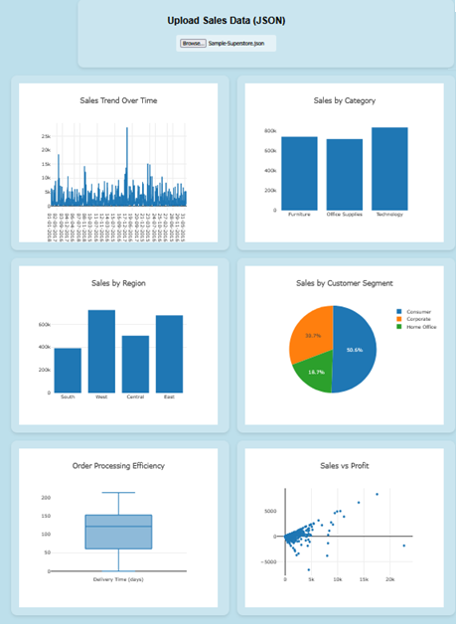

To create an interactive Excel Dashboard with ChatGPT, do the following steps -
- 1️⃣ Prepare the sample data.
  - ✅ Download / Convert your data as a CSV file (E.g. File ➡️ Export ➡️ Type CSV ➡️ Sample-Superstore.csv).
  - ✅ Convert and download your CSV file as JSON file (https://csvjson.com/csv2json) (E.g. Sample-Superstore.json).

- 2️⃣ Generate ideas for the dashboard with the help of ChatGPT.
  - ✅ Give a sample JSON record to ChatGPT and issue the following prompt -
  - 🔴 Prompt-1 - This is the structure of my sales data in JSON format. Understand the structure and suggest five key data visualization metrics that would be the best fit to create an interactive sales dashboard. Also explain why we should use each one of these visualizations?
  - ✅ Detailed suggestions from ChatGPT will be obtained.

- 3️⃣ Create the Dashboard.
  - Now for the Dashboard generation, issue the following prompt.
  - 🔴 Prompt-2 - Now, I want you to create an interactive sales performance dashboard against your suggested five key visualizations using HTML and JavaScript. Use the latest version of Plotly.js CDN and include an upload feature so that we can upload the JSON file. It should generate the dashboard based on the uploaded data. Note: I need to upload the sales data from my local computer, and it should create the dashboard based on that data.
    - ☑️ [Note: "Plotly.js CDN" refers to the Content Delivery Network (CDN) for Plotly.js, which is an open-source JavaScript library used for creating interactive charts and visualizations. A CDN is a network of servers distributed globally to deliver content, like JavaScript libraries, quickly and efficiently. Using the Plotly.js CDN allows developers to include the library in their projects by simply linking to it online, rather than downloading and hosting the files locally.]
  - ✅ The HTML code generated by ChatGPT will have to be saved against one HTML file name. (E.g. Sales_Dashboard.html)
  - ✅ To have more customizations, we can issue the following prompt (Optional).
  - 🔴 Prompt-3 - Please insert another suitable visualization of type Scatter Plot.
  - ✅ ChatGPT generated previous HTML output will be updated and revised accordingly.
  - ✅ The HTML code generated by ChatGPT will have to be saved against one HTML file name. (E.g. Sales_Dashboard.html)

- 4️⃣ Execute the HTML file.
  - ✅ Execute the HTML file and create the Dashboard by uploading the JSON file.
  - ✅ Now to do some customization we can issue the following prompt (Optional).
  - 🔴 Prompt-4 - Can you please change the layout of the Dashboard in Grid format? As two graphs per row.
  - ✅ Now revised Dashboard will be obtained by executing the HTML file with uploaded JSON file.
  - ✅ Execute the HTML file and create the Dashboard by uploading the JSON file.

